Task 3

Name: Shruti Rajesh Kayande

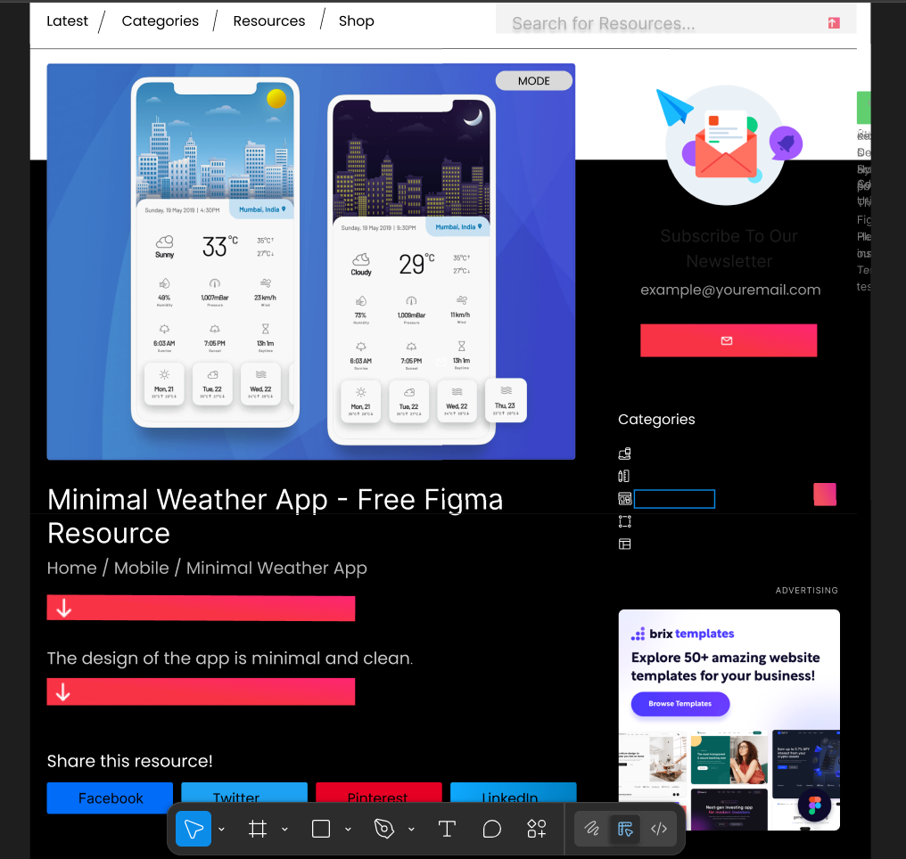

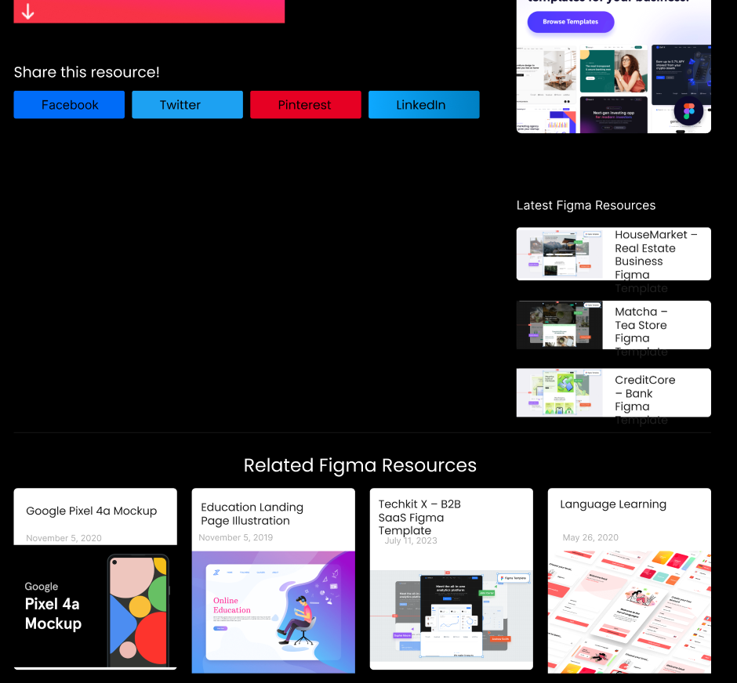

The redesigned Weather App focuses on clarity and simplicity, making it easier for users to quickly check key information like temperature and weather conditions. Typography has been improved with larger, bolder fonts, while modern, consistent icons make the interface look clean and professional. Background gradients change based on weather (e.g., sunny, rainy), adding visual appeal. The forecast section now uses scrollable cards for a more organized and interactive layout. A light/dark mode toggle enhances accessibility, and consistent spacing creates a balanced, user-friendly design. These small changes make the app look better and work smoother — perfect for beginner-level Figma practice